**Location method**

Before anything we need to know what the composition of URL is.

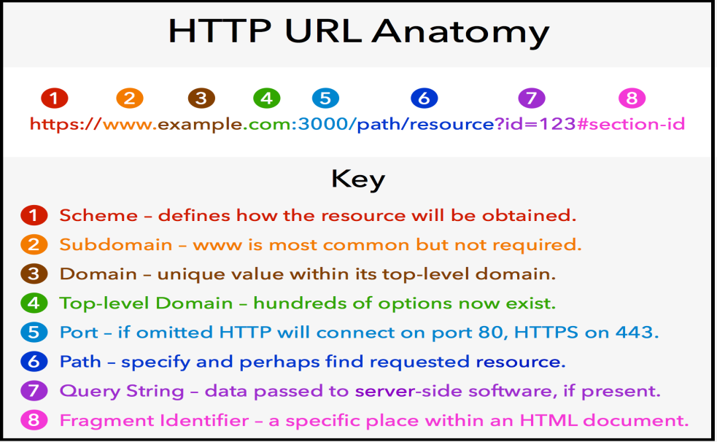

**Note:**

1. **Protocol** has several types such as: **http, https, ftp, file, mailto** each one called “**scheme**”.
2. Part **2** + **3** + **4** combined called “**Host**”.
3. Pathname starts with “**/**”.
4. Query string starts with “**?**” and it referee to the keywords that you search for within the website.
5. Fragment identifier starts with “**#**”.

Location methods are used to control on window URL, as it has some properties to do that; these properties are:

|  |  |
| --- | --- |
| **Property** | **Description** |
| Location.href | Getting the link of web page |
| location.href = “Link”; | Setting web page link to “Absolute URL” or “Relative URL” or “#Bookmark” or protocol [FTP, Mail, File] |
| Location.protocol | Getting protocol type. |
| location.protocol = “new protocol” | Setting protocol type. |
| Location.host; | Getting the host of web page |
| Location.host = “new-host” | Setting the host of web page |
| Location.pathname | Getting the path name part of the web page |
| Location.pathname = ”**/**new path” | Setting the path name part of the web page |
| Location.search | Getting query selector part (search part) in the web page. |
| location.search = “**?**keyword” | Setting query selector part (search part) in the web page. |
| Location.hash | Getting fragment identifier (bookmarks) in web page. |
| Location.hash = “**#**new-bookmark” | Setting fragment identifier (bookmarks) in web page. |

**Example:**

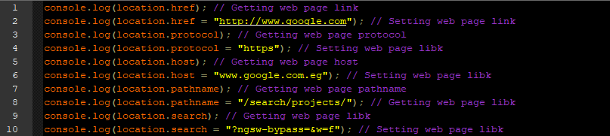

**Example:** on location.hash

